1. Changing the tags of the body of text
   1. How do apply a format (h1,h2, P etc.) of text?
      1. The text needs to be *in separate lines on screen. Separate the text using ENTER*
      2. *Highlight text and choose the appropriate format*

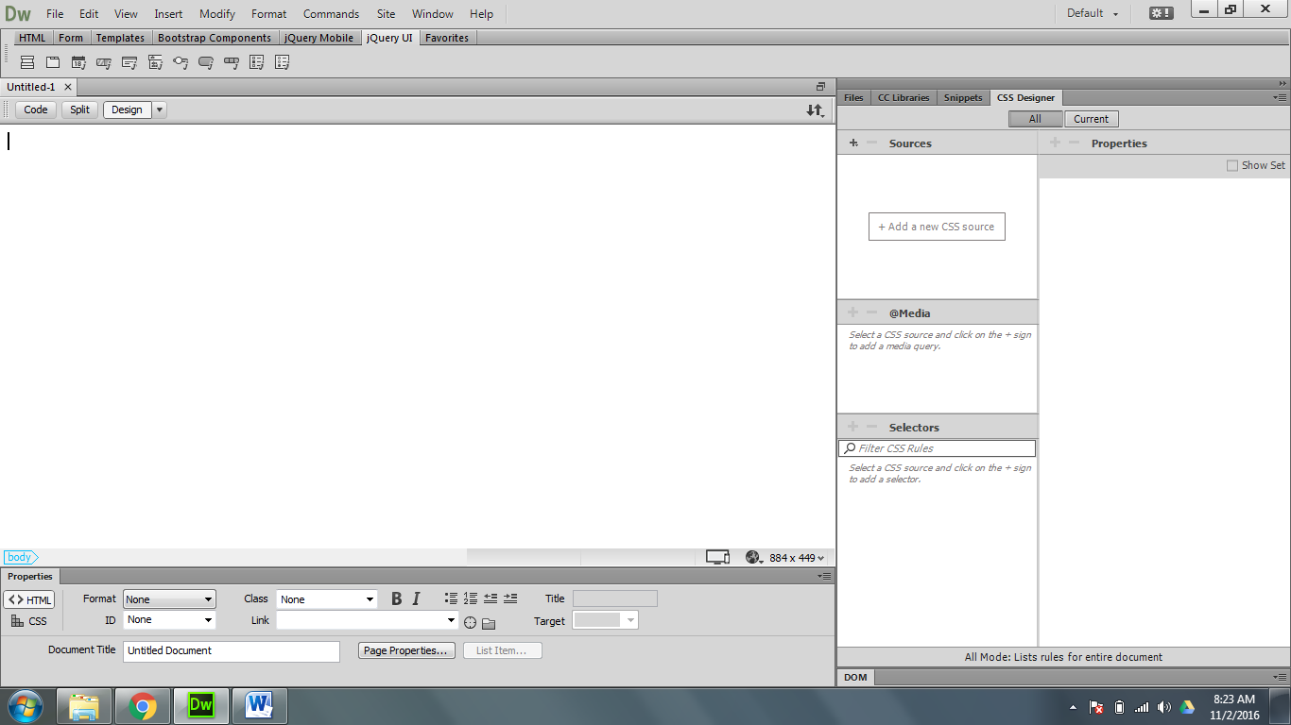

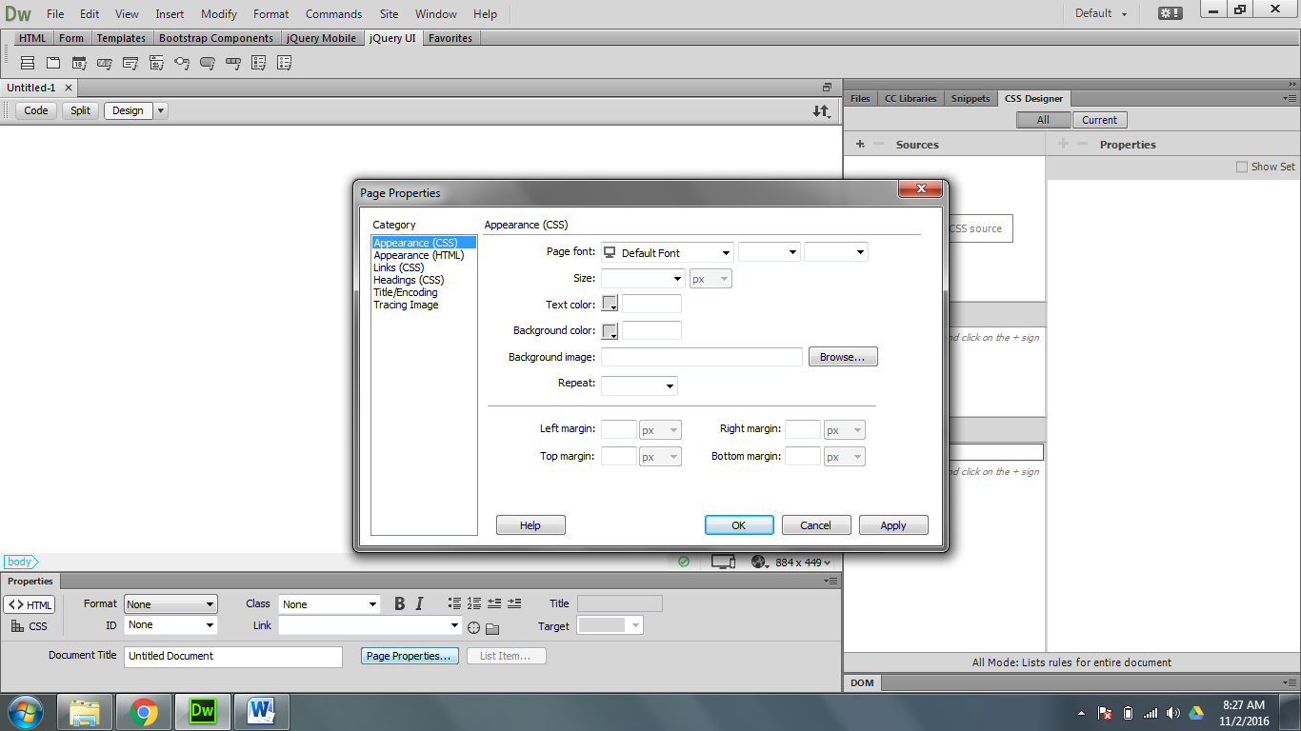

1. Page Properties
   1. Click on the heading tab in page properties
   2. What are page properties: visual properties made specifically for the current page. Every page needs page properties
   3. We can change *text color, margin size, link color, heading color etc.*
2. Creaking a link in DW- Links can only be created once the pages are finished. You can’t link to a page that hasn’t been created yet!!
   1. Highlight the text (or picture) you want to create the link.
      1. click on the folder icon next to the link menu.
      2. 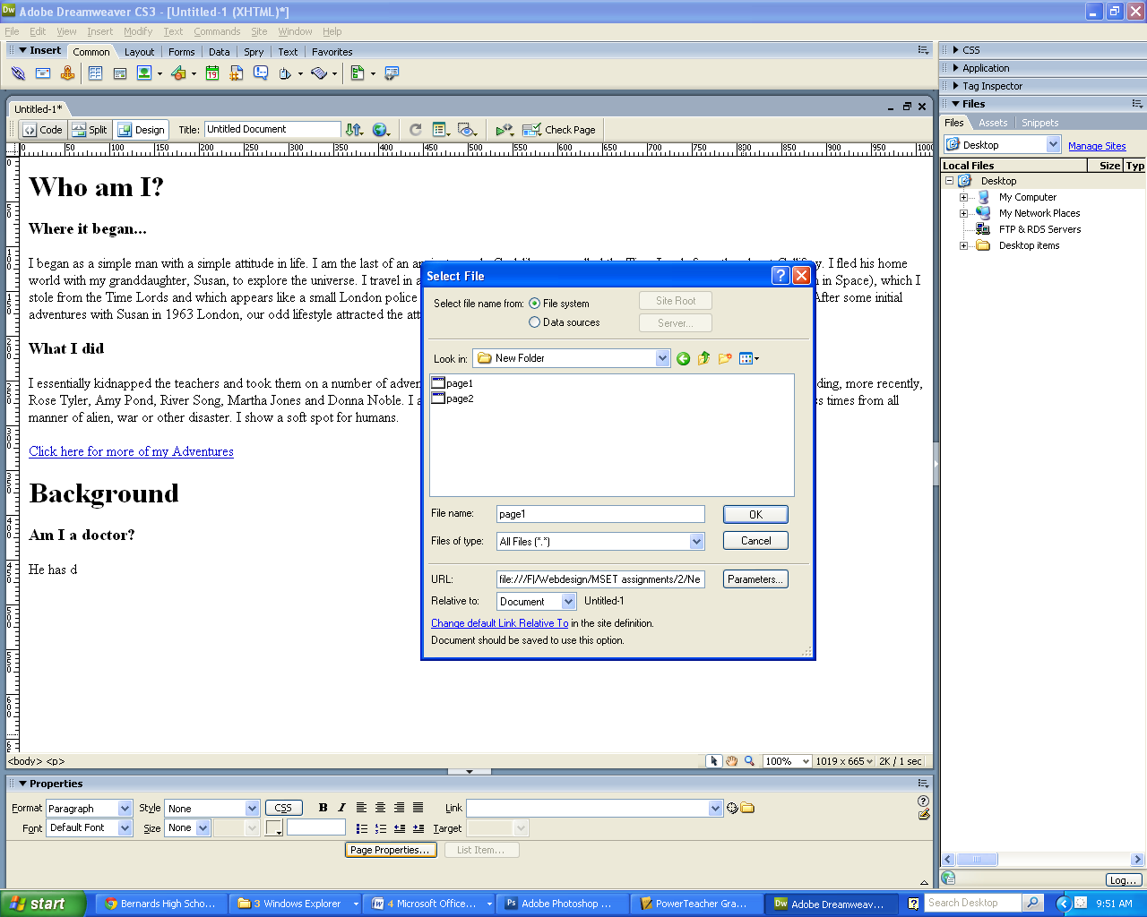Locate the specific page you need, inside your HTML root folder.